Task 1: Installing NASM
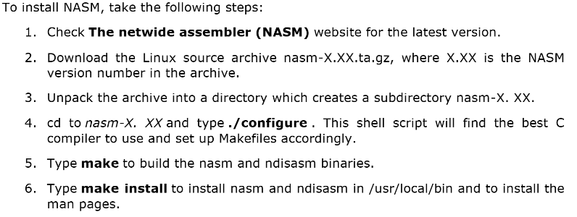
You may choose other methods. Whatever works…

Task 2: Verify Installation

- Copy the code given on the next page to a file titled “hello.asm”
- Run the following command and make sure the program runs perfectly. It should print “a=5, b=2 c=7”. You may change the values of a and b in the source code.

nasm -f elf64 hello.asm && gcc -o hello hello.o && ./hello

- End of lab for today.

extern printf
SECTION .data

a: dq 5
b: dq 2
c: dq 0
fmt: db "a=%ld, b=%ld c=%ld", 10, 0

SECTION .text

global main
main:
push rbp

mov rax,[a]
mov rbx,[b]
add rax,rbx
mov [c],rax
mov rdi,fmt
mov rsi,[a]
mov rdx,[b]
mov rcx,[c]
mov rax,0
call printf

pop rbp

mov rax,0
ret

